Deploy a simple Nginx application using AWS code commit and deploy & access via browser

**Solution:-**

Creating Code Commit Repository(Repo name -> Myrepo)

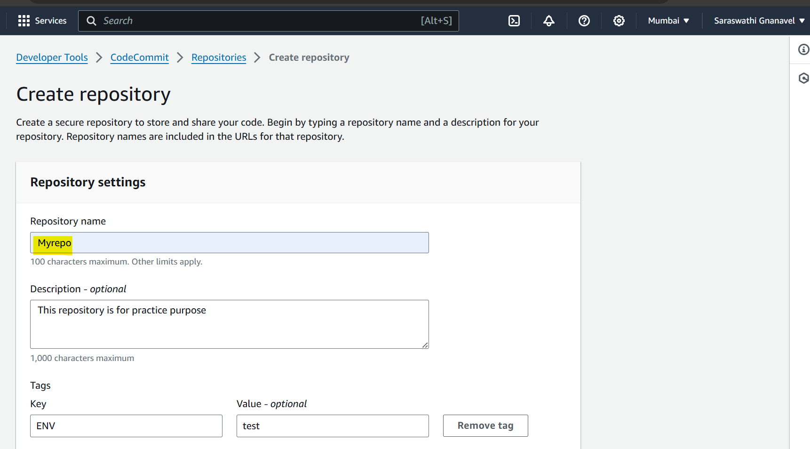

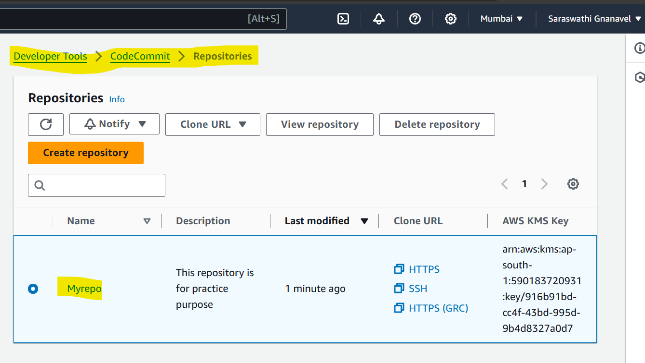

Created index.html in codecommit

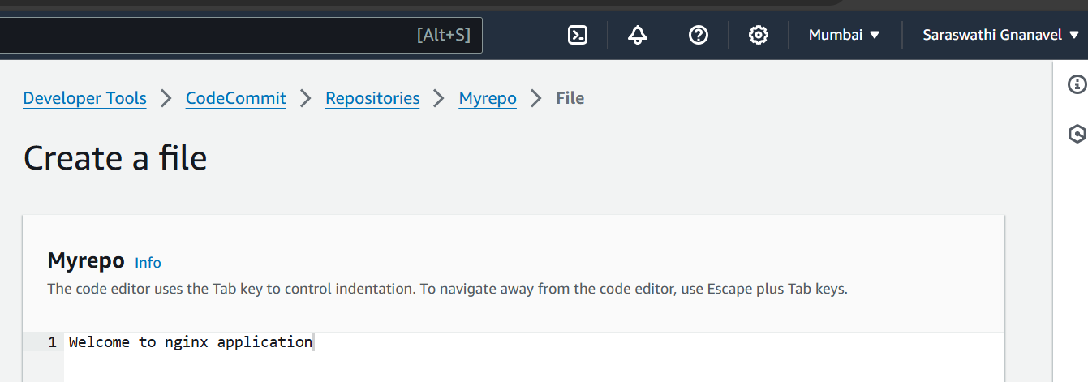

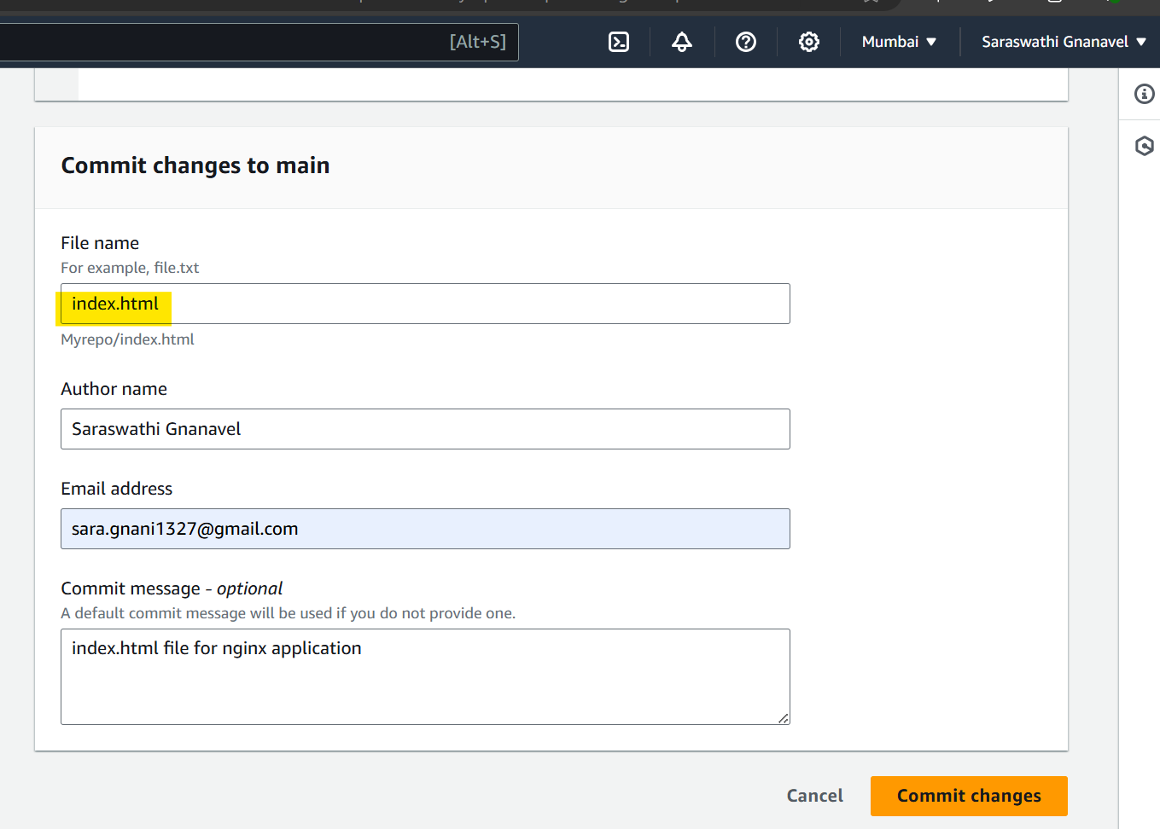

Launching an EC2 instance(named as “test”)

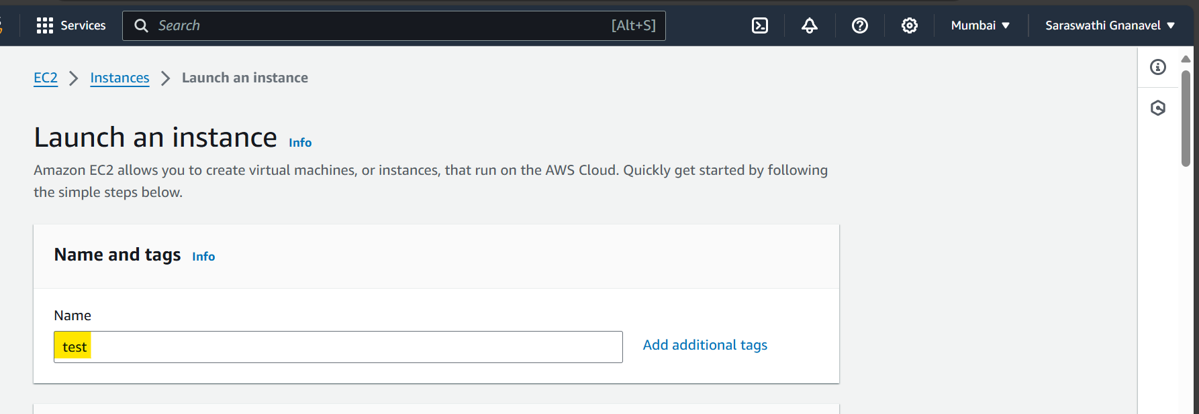

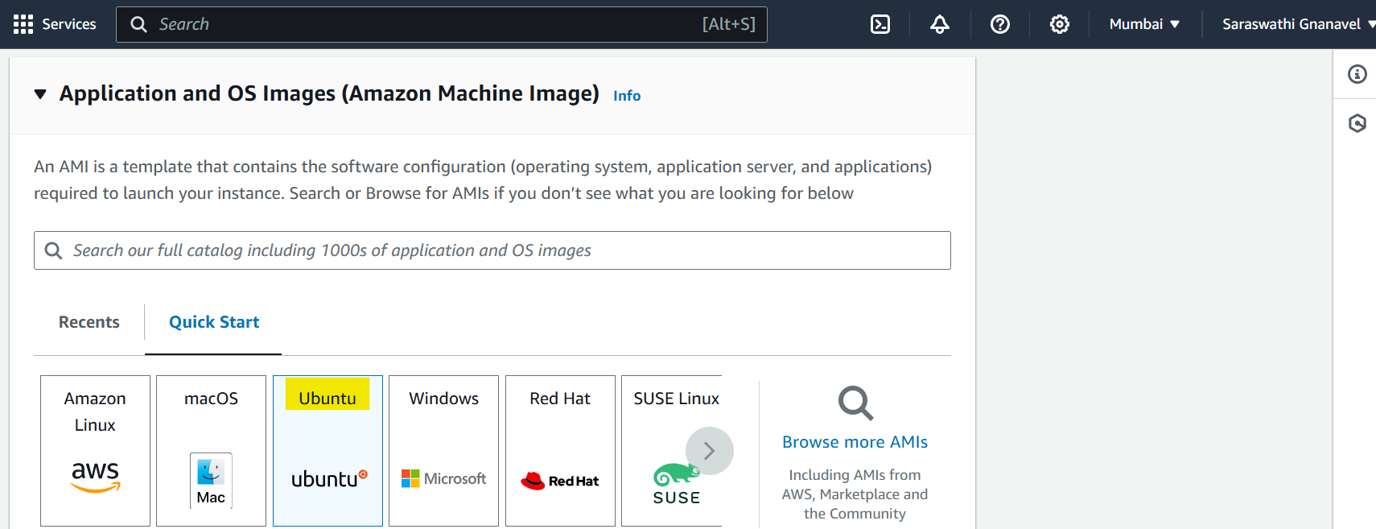

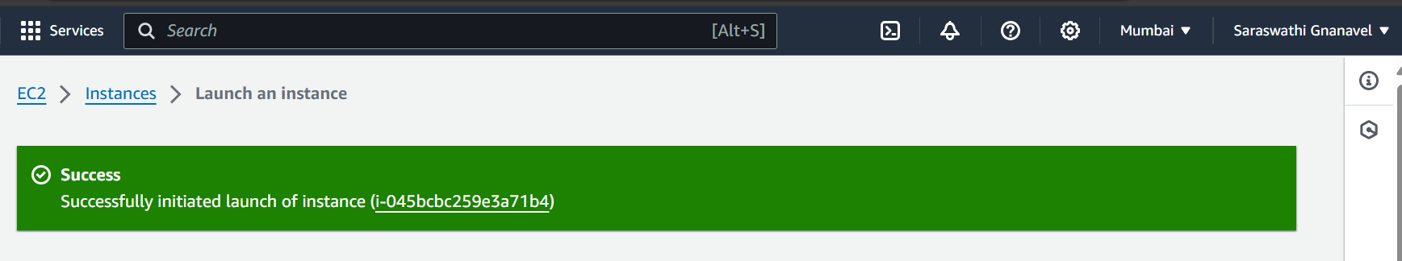

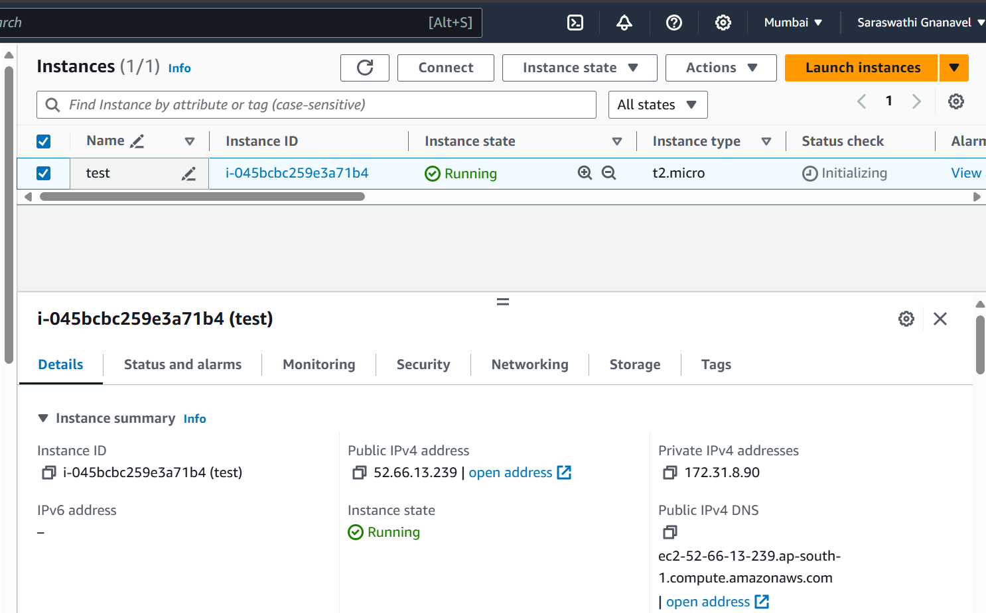

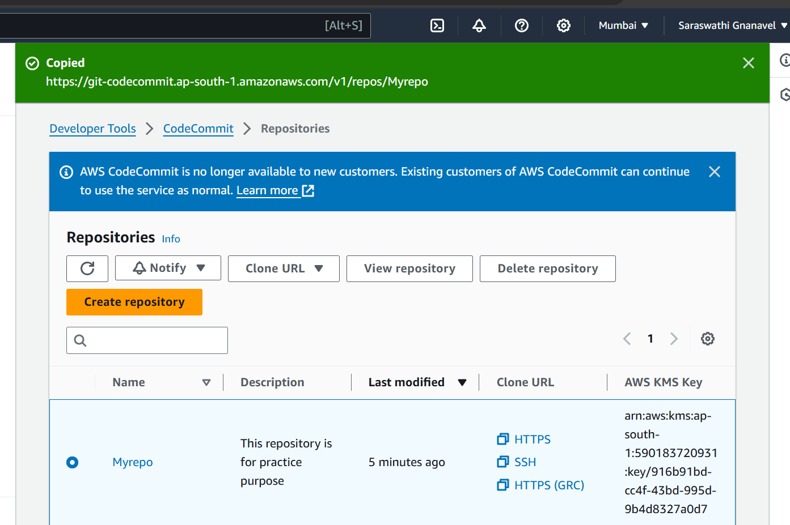

My-repo https url 🡪 <https://git-codecommit.ap-south-1.amazonaws.com/v1/repos/Myrepo>

Accessing Security credentials at AWS IAM to grab the username & password

Created an user(Named as saraswathi)

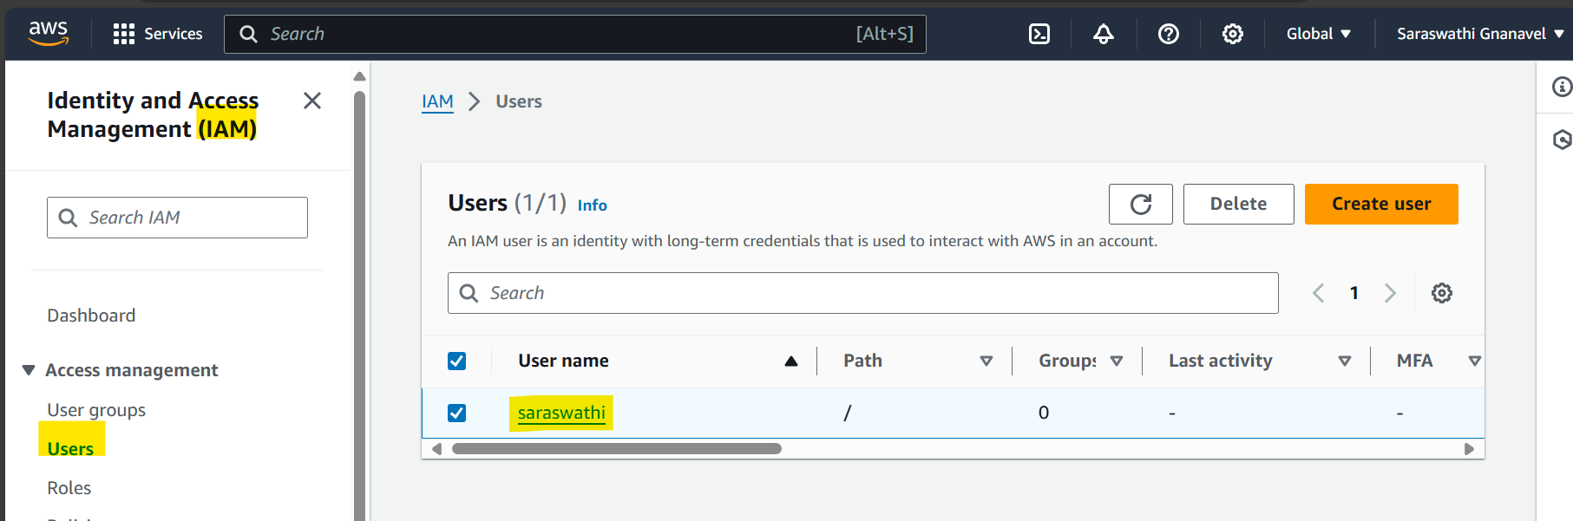

Adding Permission policy to User:- Saraswathi so that the user can able to access codecommit in EC2 instance

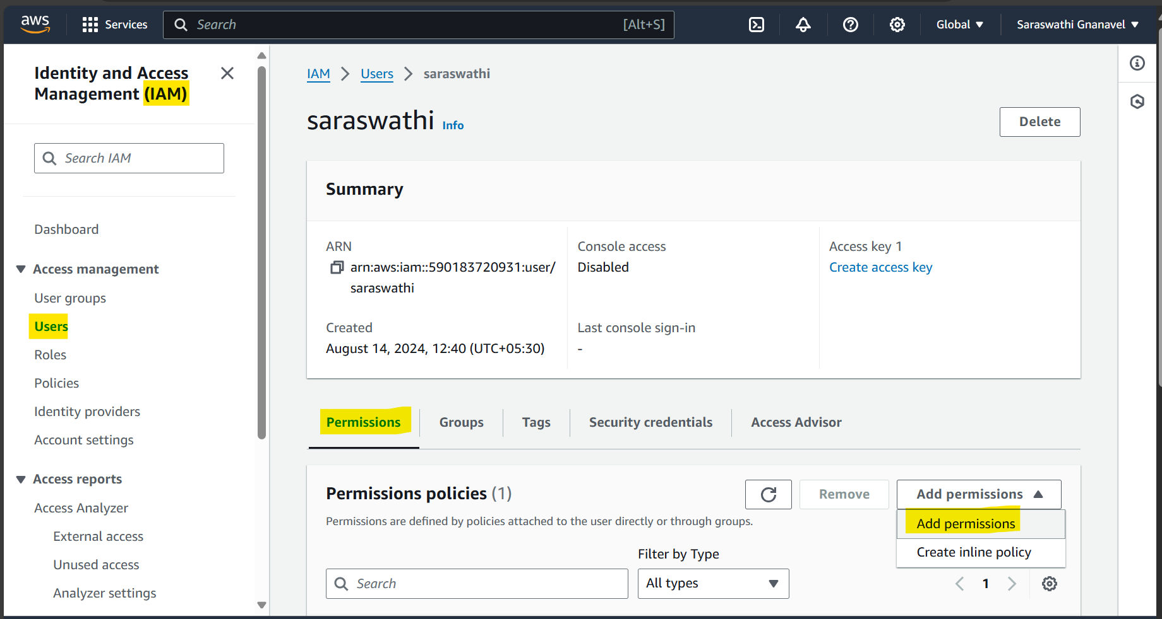

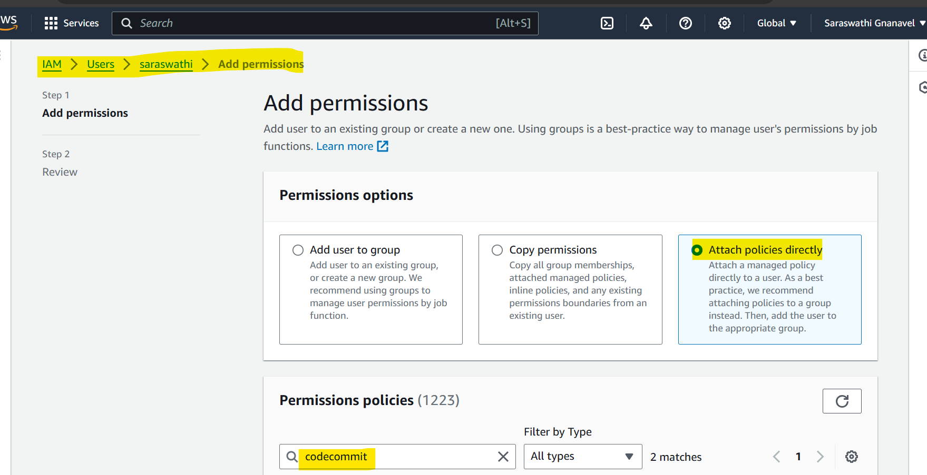

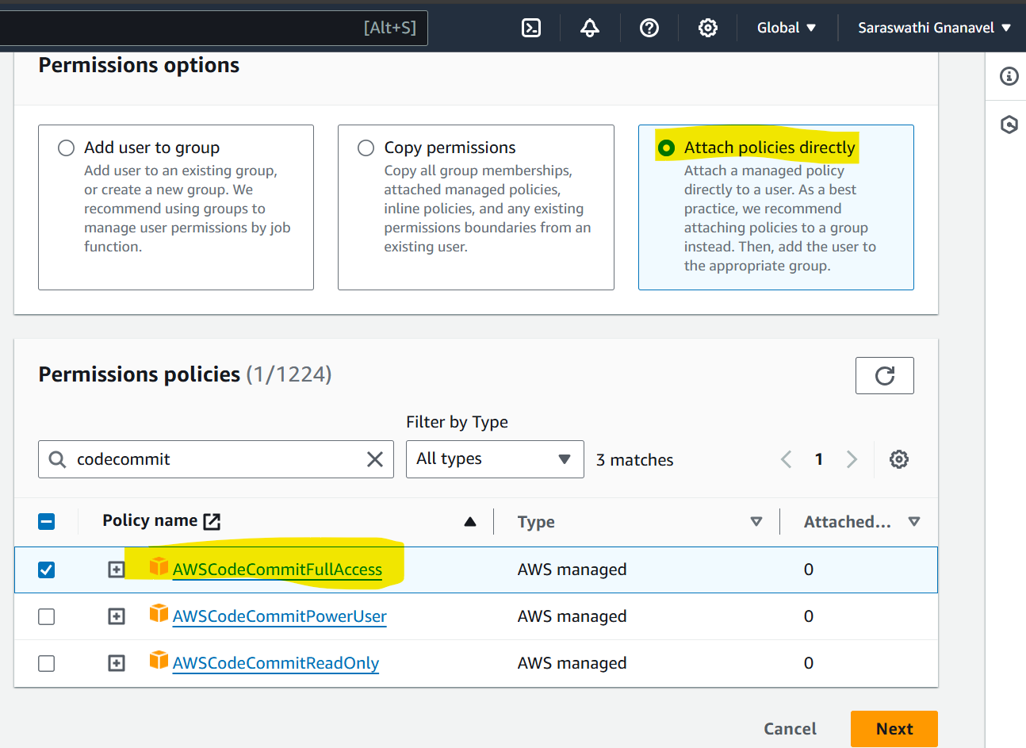

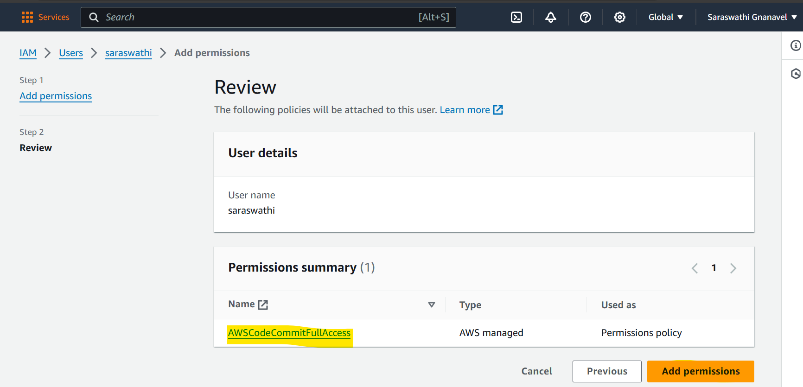

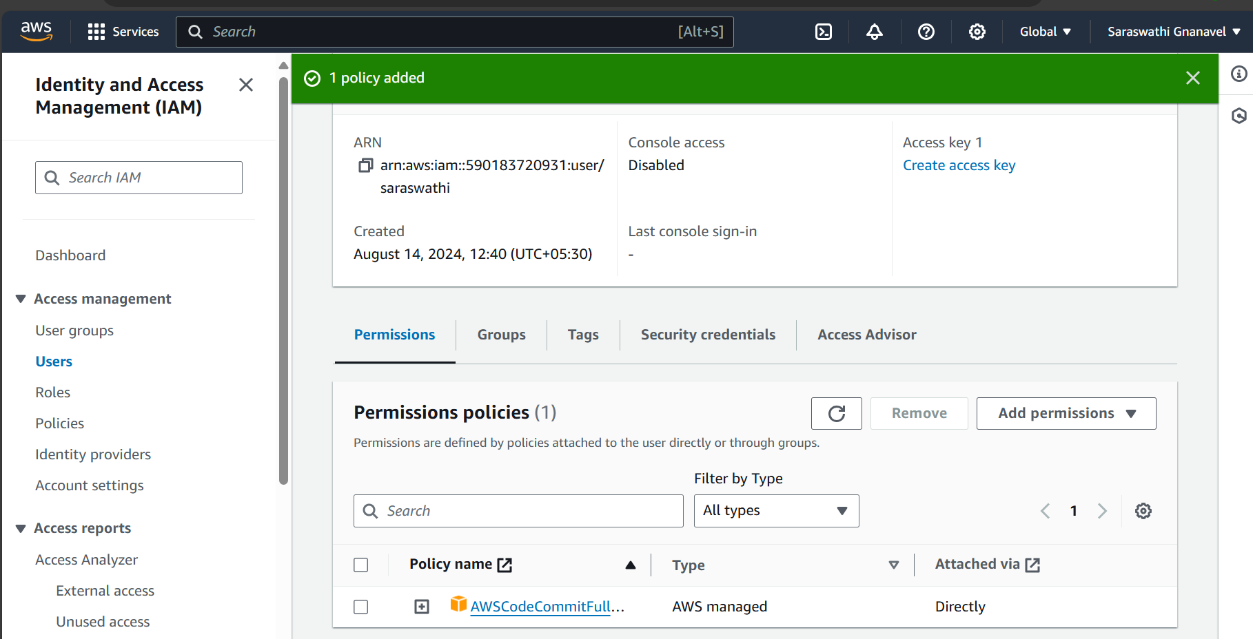

Now go to security credentials to grab the username and password

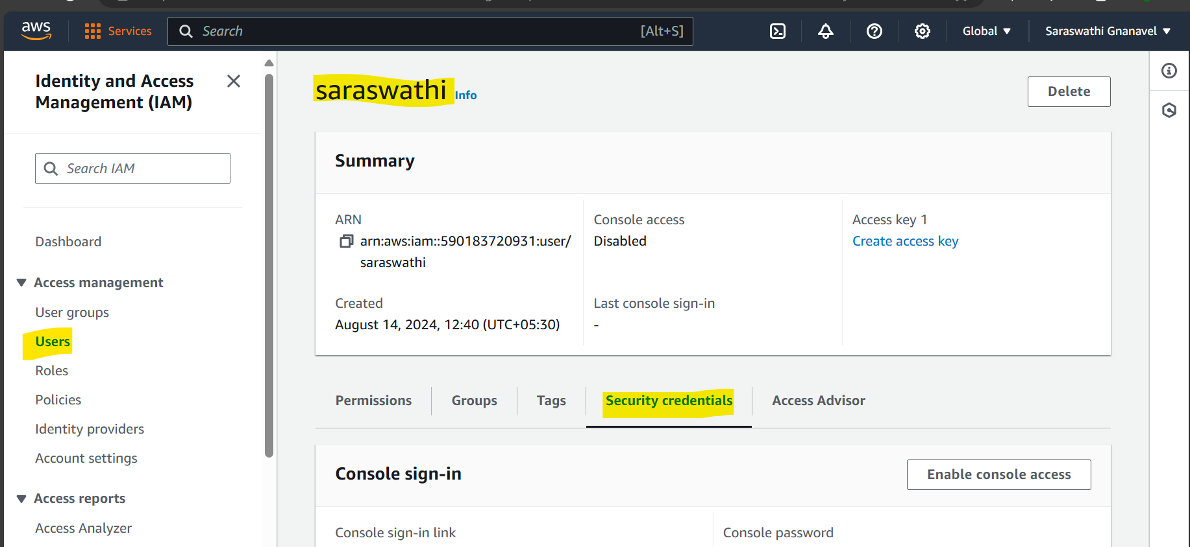

Scroll-down to “**HTTPS Git credentials for AWS CodeCommit”** and select “**Generate credentials**”

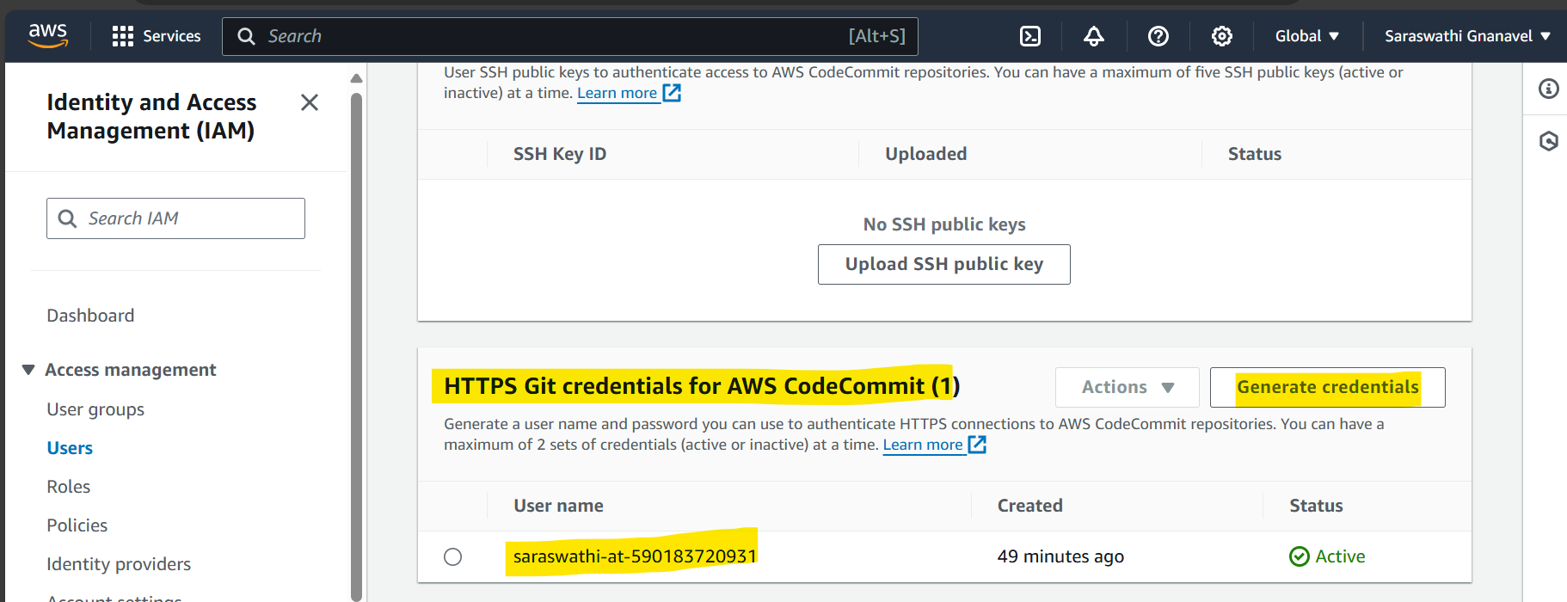

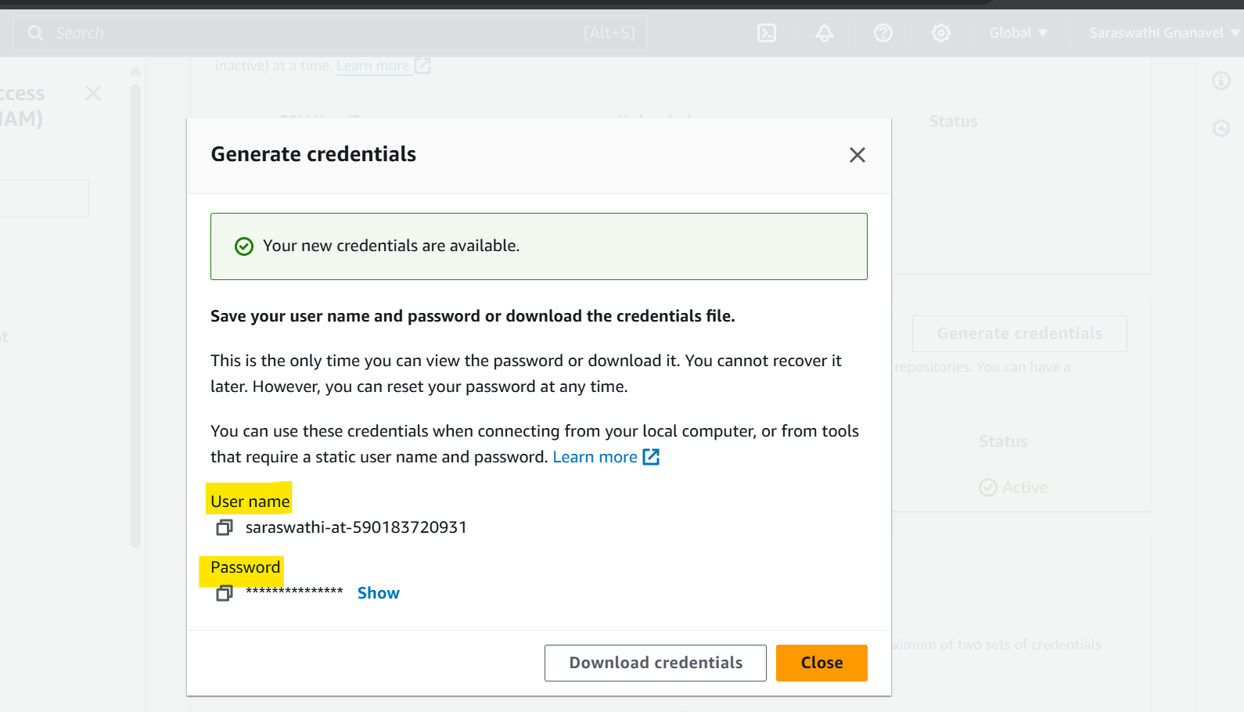

Now go to EC2 instance🡪 test, clone the codecommit by providing the below commands

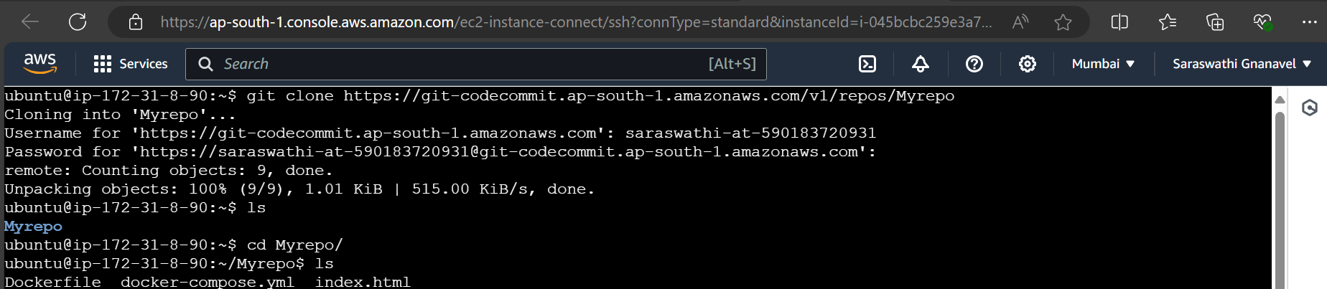

We have installed nginx application

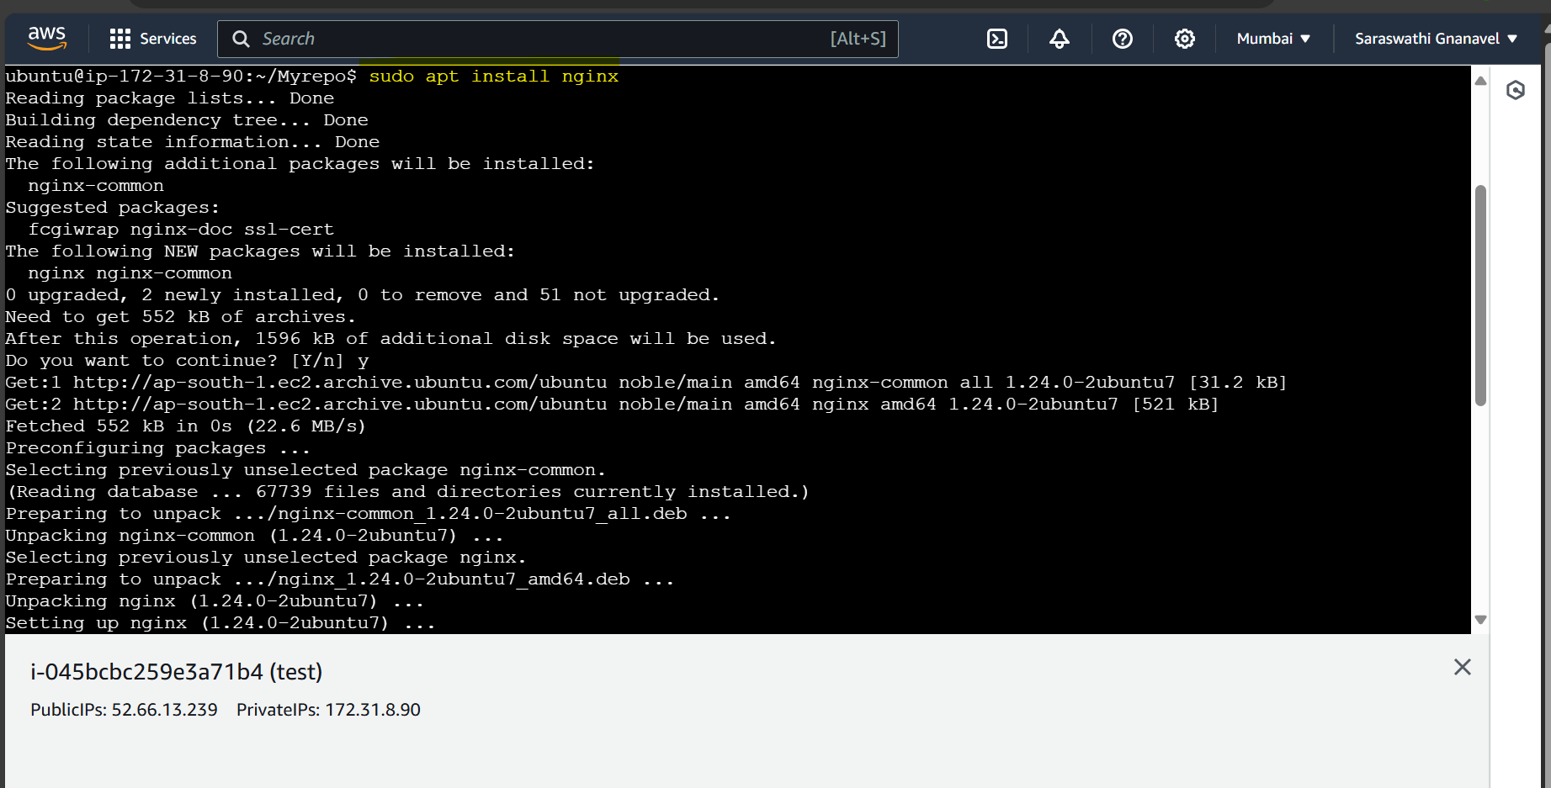

Now after installation of nginx application in EC2 instance, copied the index.html file from codecommit and pasted at /var/www/html

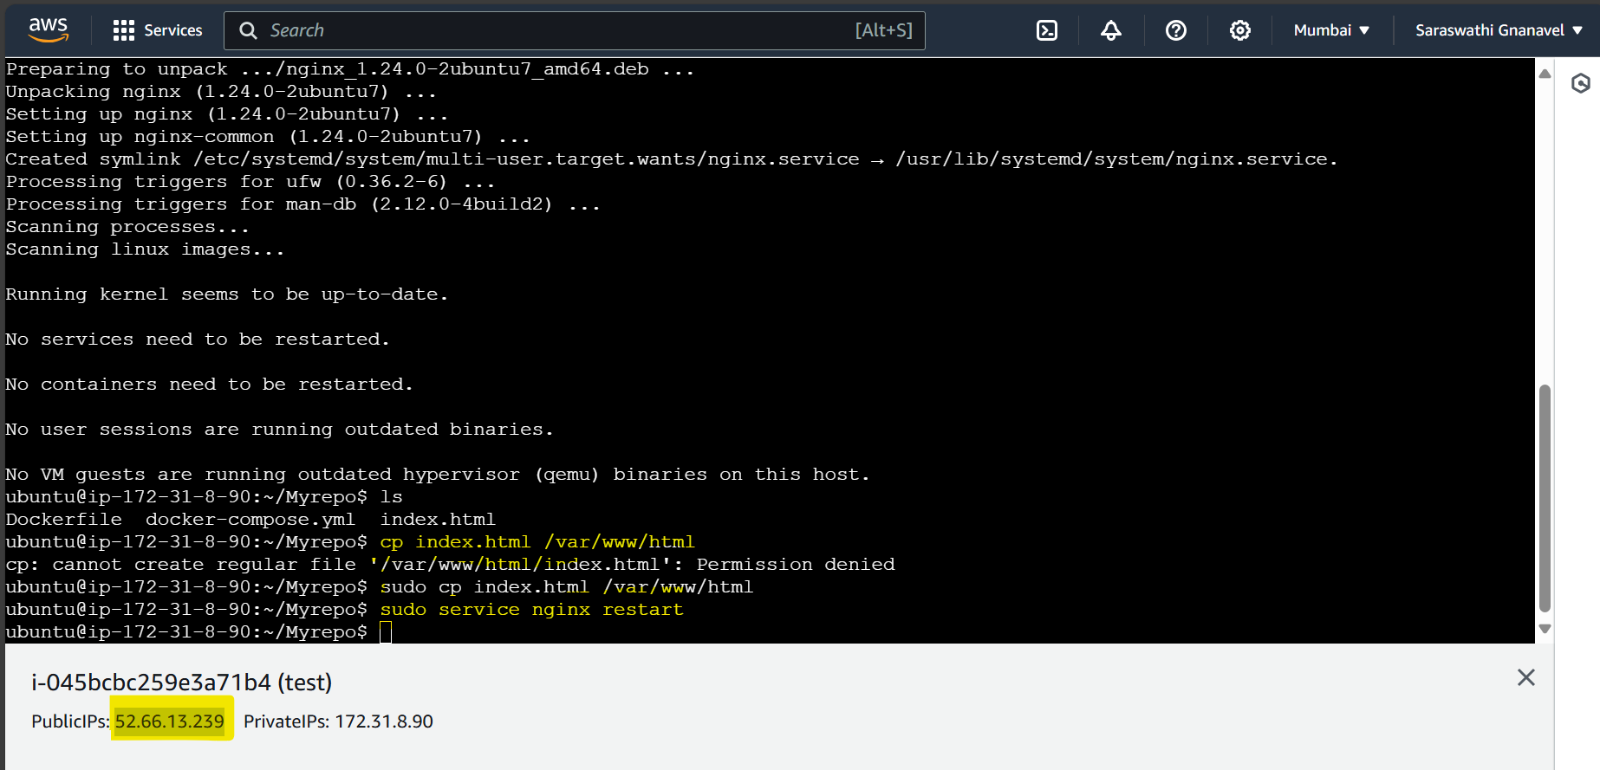

Updated EC2 Instance’s security group to accept ipv4 from anywhere

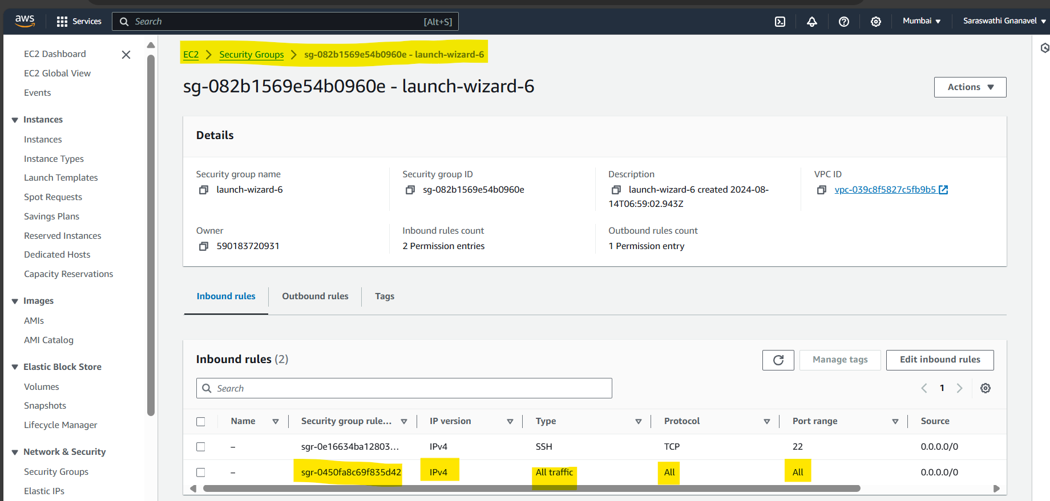

Now try to run the nginx app by using the Public IP address of EC2 Instance

